TASK : 01

With the help of manipulator functions write the program that produces the following output

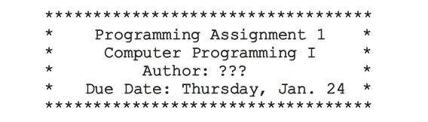

**Source Code:**

//including Library "iostream" "iomanip":

#include<iostream>

#include<iomanip>

using namespace std;

int main()

{

//With the help of library(iomanip) producing a program:

cout<<"\n"<<"\t"<<"\t"<<setfill('*')<<setw(42)<<"\n"

<<"\t"<<"\t"<<setfill('*')<<setw(2)<<"\t"<<"Programming Assignment 1"<<"\t"<<setw(2)<<"\n"

<<"\t"<<"\t"<<setfill('*')<<setw(2)<<"\t"<<"Computer Programming I"<<"\t"<<"\t"<<setw(2)<<"\n"

<<"\t"<<"\t"<<setfill('*')<<setw(2)<<"\t"<<" Author: ???"<<"\t"<<"\t"<<setw(2)<<"\n"

<<"\t"<<"\t"<<setfill('*')<<setw(2)<<"\t"<<"Due Date:Friday.Feb.24 "<<"\t"<<setw(2)<<"\n"

<<"\t"<<"\t"<<setfill('*')<<setw(42)<<"\n";

//end program:

return 0;

}

**Snapshot:**

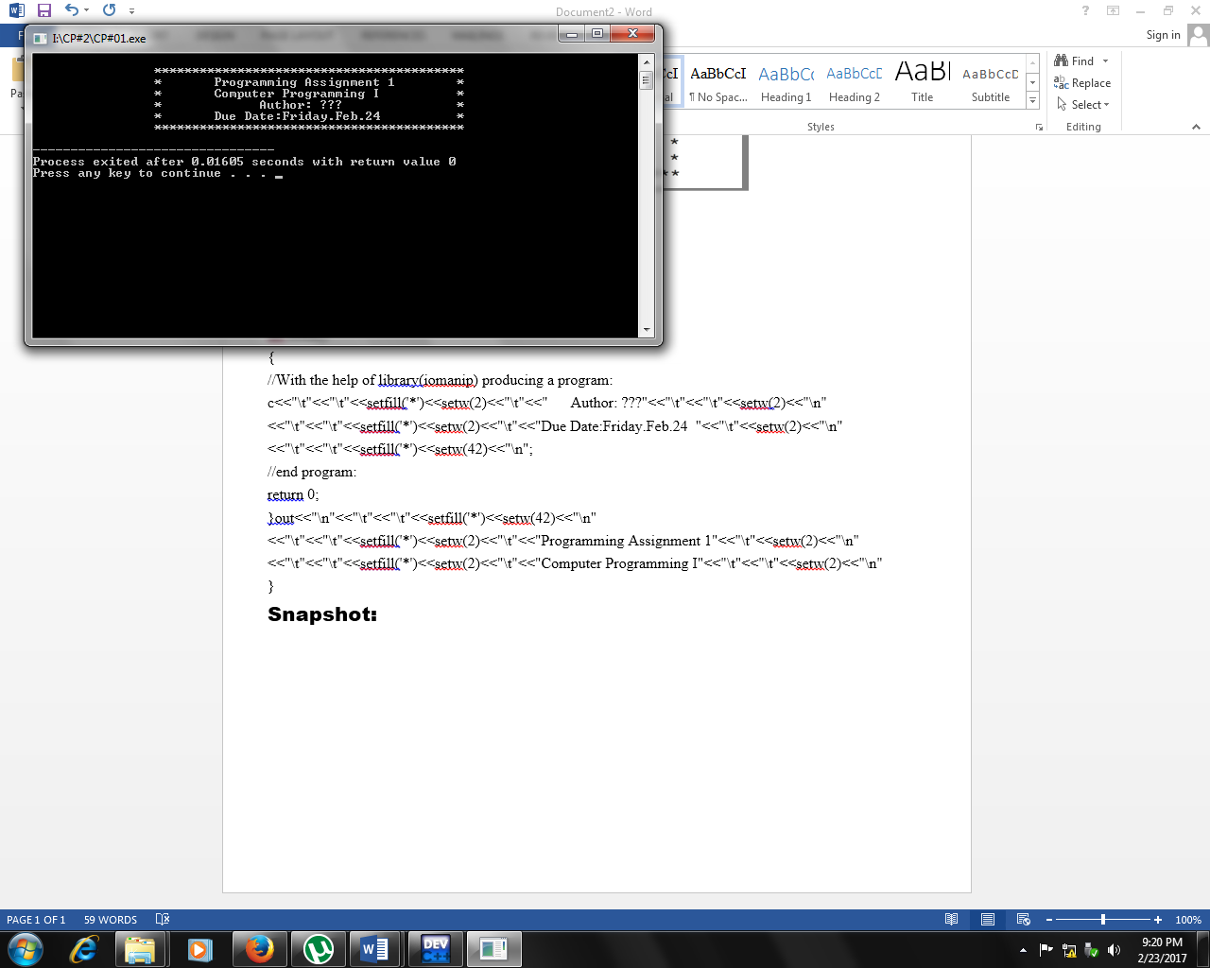

TASK : 02

To make a profit, a local store marks up the prices of its items by a certain percentage. Write a C++ program that reads the original price of the item sold, the percentage of the marked-up price, and the sales tax rate. The program then outputs the original price of the item, the percentage of the mark-up, the store’s selling price of the item, the sales tax rate, the sales tax, and the final price of the item. (The final price of the item is the selling price plus the sales tax.)

Source Code:

#include<iostream>

using namespace std;

int main()

{

//Declaring variables:

float a,b,c,d,e,f;

//Original Price of item:

cout<<"Original Price of item in $= ";

cin>>a;

// % of Mark-up price:

cout<<"Percentage of marked-up prince in $= ";

cin>>b;

//Sales Tax price:

cout<<"Sales tax percentage in $= ";

cin>>c;

//Original Price of item:

cout<<"\n"<<"\n"<<"\t"<<"Original price ="<<a<<"$"<<"\n"<<endl;

//Calculate Mark-up price:

d=a*b/100;

cout<<"\t"<<"Mark-up Price ="<<d<<"$"<<"\n"<<endl;

//Calculate Sales Tax price

e=a*c/100;

cout<<"\t"<<"Sales Tax Price ="<<e<<"$"<<"\n"<<endl;

//Calculate Total price:

f=a+e+d;

cout<<"\t"<<"Total Price ="<<f<<"$"<<"\n"<<endl;

return 0;

}

Snapshot:

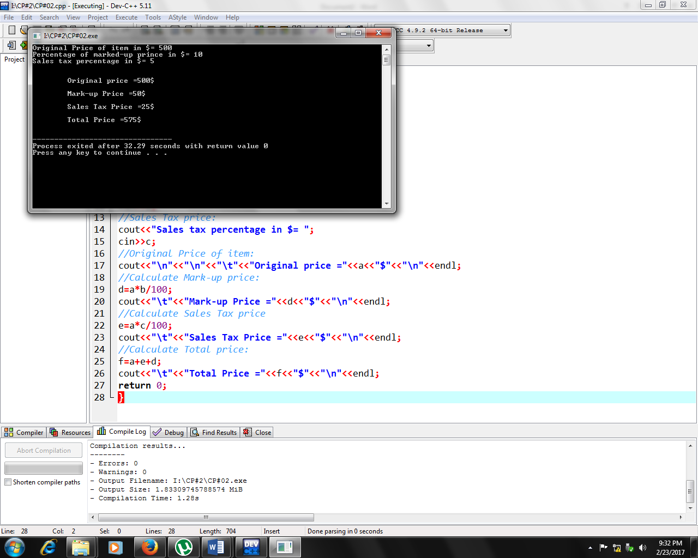

TASK : 03

**Write a program that prompts the user to enter the weight of a person in kilograms and outputs the equivalent weight in pounds. Output both theweights rounded to two decimal places. (Note that 1 kilogram ¼ 2.2pounds.) Format your output with two decimal places.**

**Source Code:**

//including Libraries "iostream" &"iomanip":

#include<iostream>

#include<iomanip>

using namespace std;

int main()

{

//Declaring variable:

float a,b,c;

//Weight of person in kg:

cout<<"Weight of a person in kg= ";

cin>>a;

b=a*2.2;

//Weight of person in pound:

cout<<"\n"<<setprecision(2)<<fixed<<"Weight of a person in Pounds= "<<b;

return 0;

}

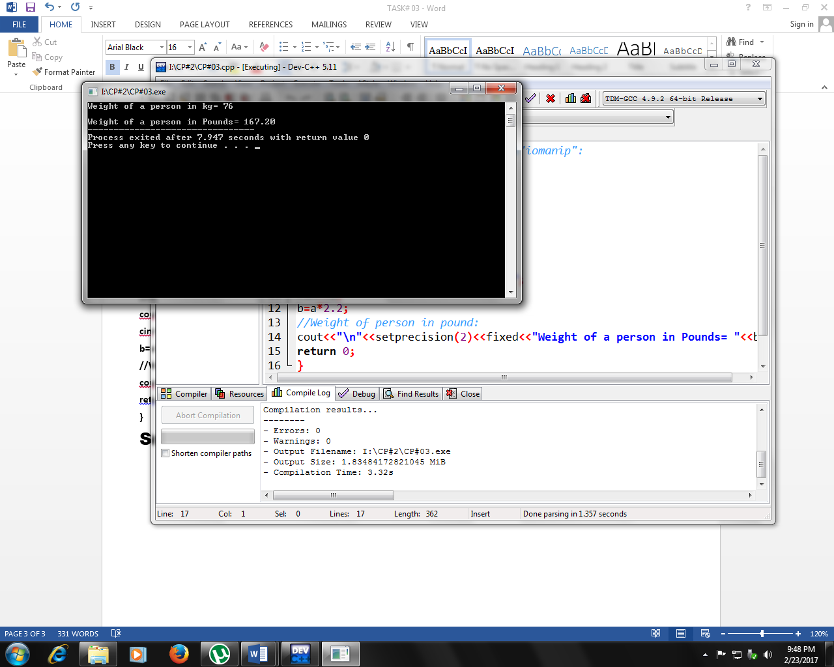**Snapshot:**